## Activity Packages

Activity packages are used by sites to group together activities that registrants need to be enrolled congruently i.e. registrants must complete 3 out of 5 activities to earn certification.

Other sites use activity packages to ease online registration into multiple activities i.e. online customers can select multiple activities in one page instead of going back and forth between pages and adding activities separately.

## Creating Activity Packages

First, you will want to create an activity type called "activity package" which has the "Activity Lists" checked off.

### To Create an Activity Type

1. Go To: Administration Home » Registration Settings » Activity Types  
2. **Click** on “Add New”  
3. Make sure “Activity Lists” is checked and then save.

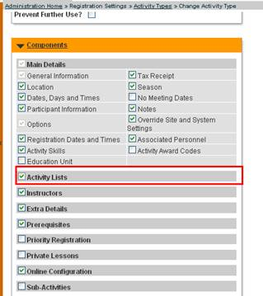

Once you have created an activity type for packages, you will want to create one activity that will act as the 'package'. When you create this activity you will want to put the activity type as "activity package." You will then create other activities as regular classes (so activity type will be "classes"). You can then add all of these classes to the activity package class you first created by going to the functions page and clicking "add new activity list."

So there will only be one class that has the activity type as "activity package" and all the rest will be "classes."

### To Create an Activity Package:

1. Create your  activities as separate classes (as per usual)  
2. Go To: Administration > Registration Settings > Activities > Add New  
3. Choose “Activity Package” as your “Activity Type”  
               -Your dates for this package should encompass the dates for your  activities, but you may want to select the box that says “do not create  meeting dates  
4. Save your new Activity Package  
5. In the Activity Package Functions section click on the option “Change Activity List” and click “Add New”

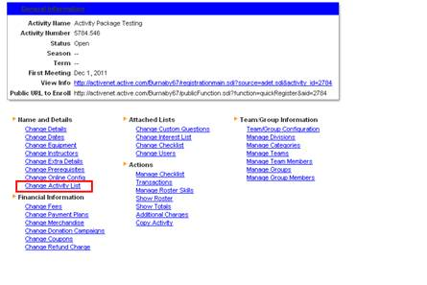

6. Find your activities and add them under “Activity”  
7. Choose all of the options as seen below.

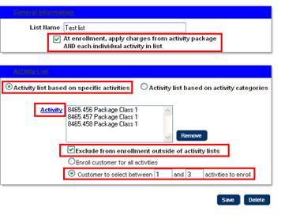

You have now created an Activity Package with these three classes attached. The last checkbox is where you can assign to select between 1 and 1 so they have the choice of only one class.

## Considerations

You will not be adding a charge at the package level; you will be creating the charges at the individual activity level.